**LINK ECU CAN output config in Haltech V2 format**

This document details how to setup your LINK ECU with the predefined ICS files to get your CAN output in the Haltech V2 format. LINK ECU’s PCLINK Sofware defines the CAN ID’s in decimal format. Link ECU’s allow for a maximum of 6 Channels (ID’s) .I have created some ICS files that can be loaded directly in the PCLINK software for easy setup

Stream1_LINK_HaltechV2_Message_ID864_(0x360).lcs

* RPM
* MAP
* TPS
* No data

Stream2_LINK_HaltechV2_Message_ID865_(0x361).lcs

* Fuel Pressure
* Oil Pressure
* No data
* No data

Stream3_LINK_HaltechV2_Message_ID992_(0x3E0).lcs

* Water Temperature
* Intake Temperature
* Fuel Temperature
* Oil Temperature

Stream4_Not yet done

* No data
* No data
* No data
* No data

Stream5_Not yet done

* No data
* No data
* No data
* No data

Stream6_Not yet done

* No data
* No data
* No data
* No data

**Configure the Channels 1-3**

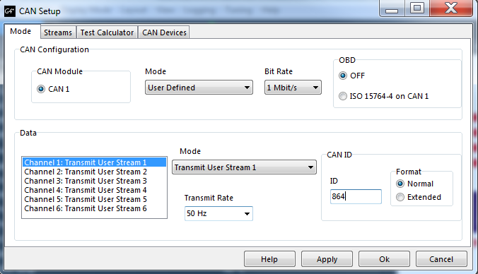

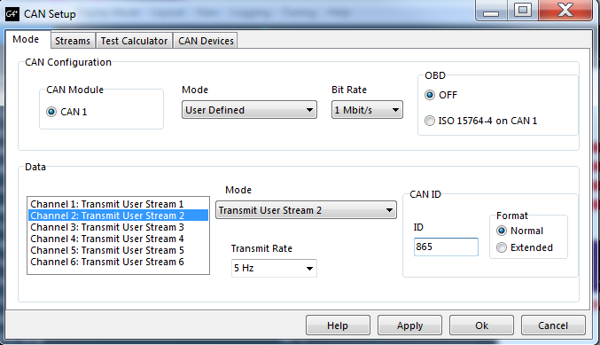

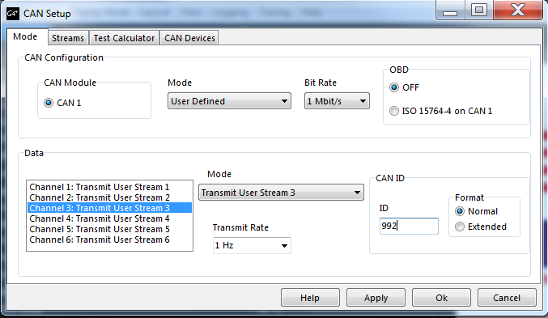

**Configure Stream 1**

Go to the Tab „Streams“

* Right click Stream 1 and select “Load Stream”
* Select the file “Stream1_LINK_HaltechV2_Message_ID864_(0x360).lcs”

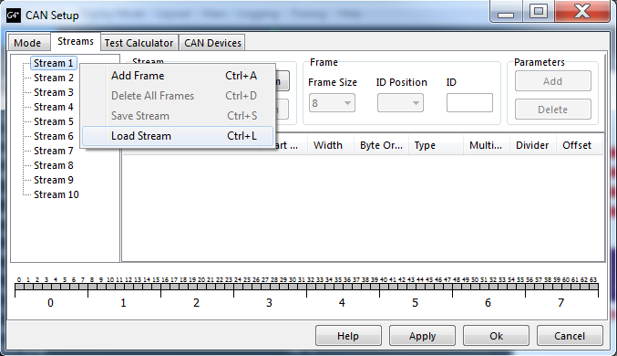

After Loading the file the Stream 1 should look like this :

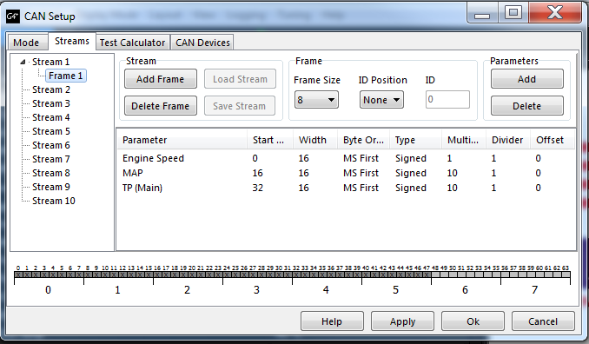

**Configure Stream 2**

* Right click Stream 2 and select “Load Stream”
* Stream2_LINK_HaltechV2_Message_ID865_(0x361).lcs

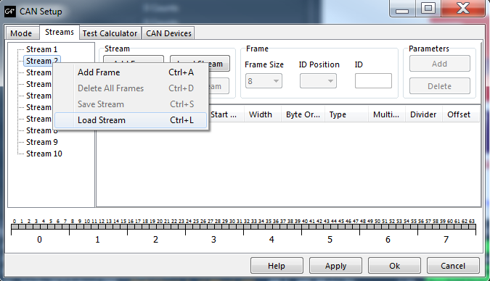

After Loading the file the Stream 2 should look like this :

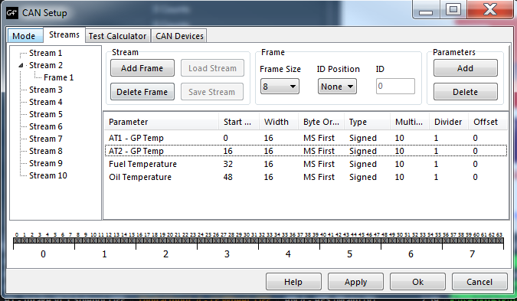

**Configure Stream 3**

* Right click Stream 3 and select “Load Stream”
* Stream3_LINK_HaltechV2_Message_ID992_(0x3E0).lcs

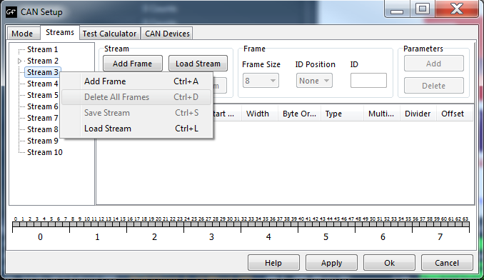

After Loading the file the Stream 3 should look like this :

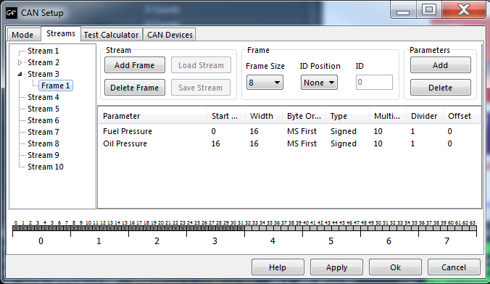

**Configure Stream 4**

**Configure Stream 5**

**Configure Stream 6**